In the name of god







***Producers :***

*Sayyed Hossein Hosseini*

*Hanieh Shams*

***Supervisor :***

*Dr. Mohammad Reza Sharbaf*

***Teacher assistant :***

*Reza Pour Mohammadi*

***Faculty of Computer Engineering, University of Isfahan***

***Autumn 2023***

Table of Contents

**[Amazon Go (Demo version in Dorna HQ)1](#_Amazon_go_(demo)**

Home Page1

Register Page1

Login Page2

Customers Page2

Companies Page3

Transactions Page3

### Amazon go (demo version in dorna hq:

In this part, we will deal with the design of the demo version of the project, the designed images can be seen in this documentation.

### Home page:

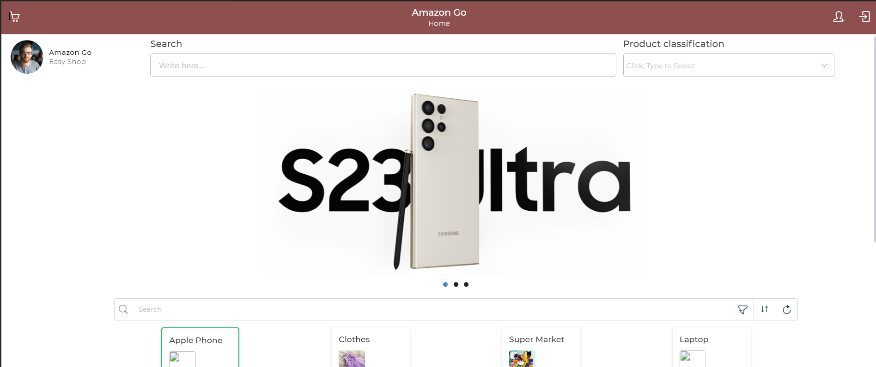

### register page:

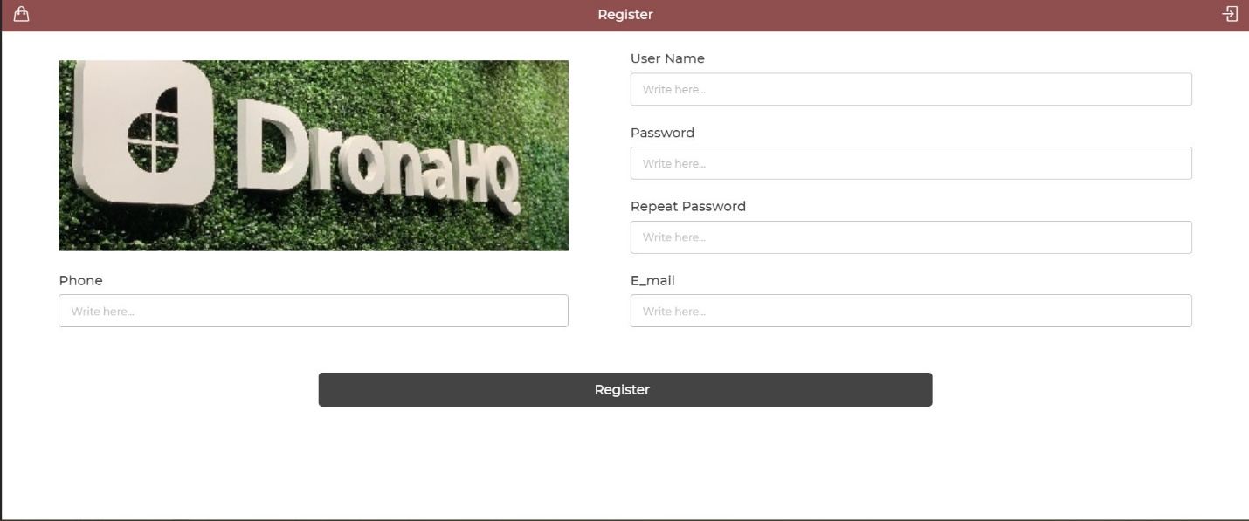

1

### login:

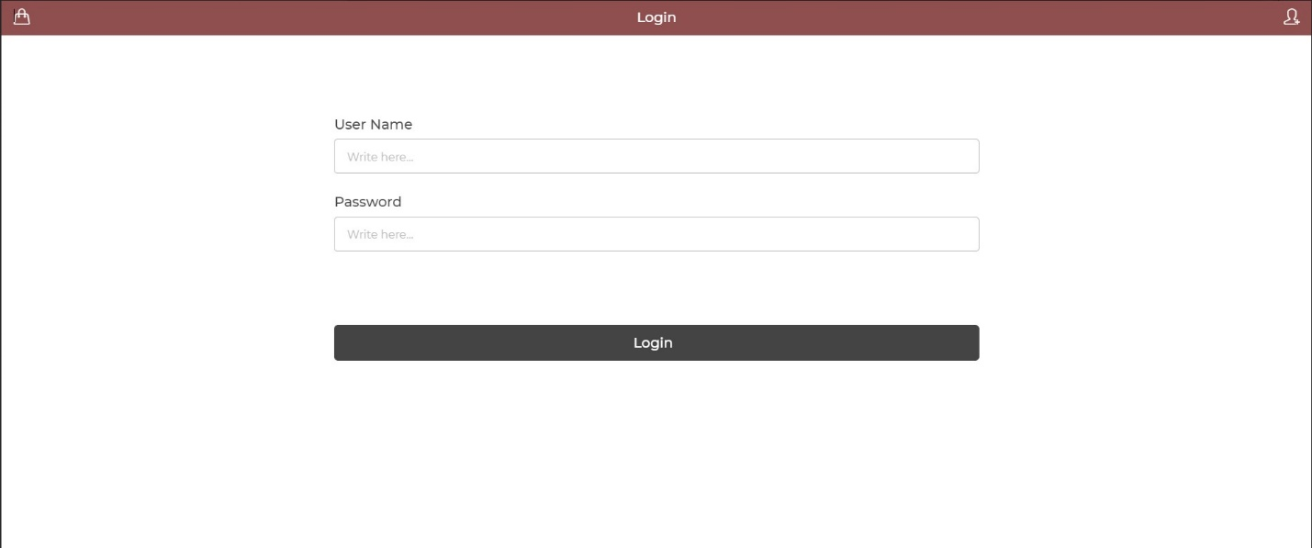

### customers page:

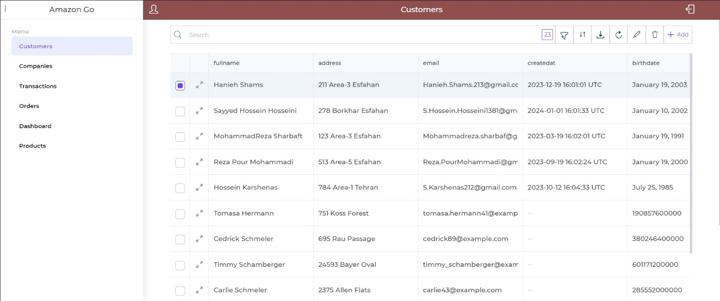

2

### companies page:

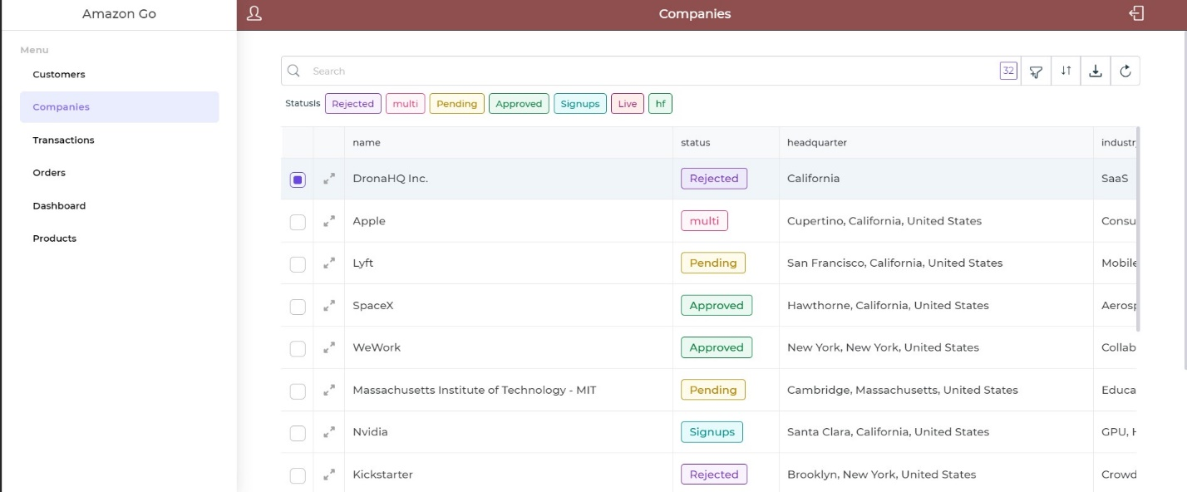

### transactions page:

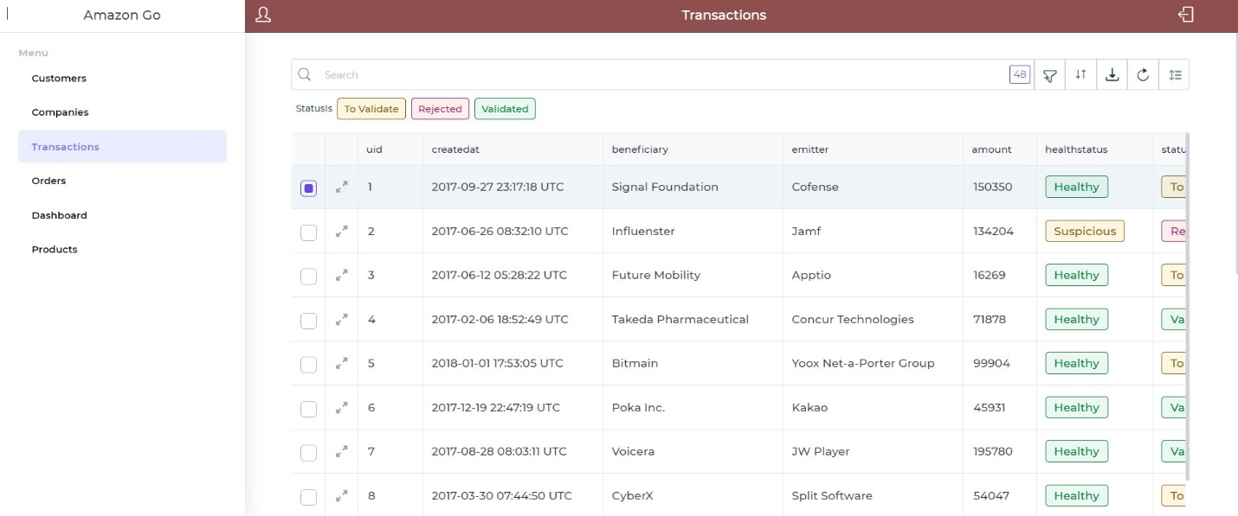

3